Predicting Credit Card Customer Default Risk Using Machine Learning

Business Problem
Today’s economy is highly dynamic, and financial conditions can change rapidly for consumers and financial institutions. Many individuals experience events such as job loss, divorce, illness, or other financial hardships that can negatively affect their ability to repay debt. These events present considerable financial risk to banks and financial institutions that issue credit cards to their customers. In this environment, default prediction has become increasingly important. Banks can use machine learning techniques to identify customers who may be more likely to default on their credit card obligations.
The purpose of this project is to develop and evaluate machine learning models that can predict possible credit card default accounts using predictive analytics techniques. By identifying potentially delinquent customers early, financial institutions may reduce losses, improve portfolio management, and make more informed lending decisions.
This project attempts to answer several important business and research questions, including whether gender or age has any relationship with default risk, which variables are the strongest predictors of default, whether education level affects repayment behavior, and which machine learning model performs best for predicting credit card default.

Background and History
Credit cards provide consumers with convenient access to revolving credit and borrowing. However, because transactions are primarily digital, many consumers may underestimate the amount of debt they accumulate over time. It is relatively easy for customers to use credit cards for expensive purchases, vacations, or discretionary spending while assuming future income will allow them to repay balances later.
Banks issue credit cards to customers who appear financially capable of servicing debt at the time of approval. However, financial conditions can change significantly after a card is issued. As a result, repayment ability is never guaranteed.
Traditionally, banks assess lending risk using standardized credit scores, historical credit bureau data, and the framework commonly referred to as the “Five Cs” of credit: Character, Capacity, Capital, Collateral, and Conditions. Financial institutions evaluate a borrower’s payment history, ability to repay debt relative to income, financial reserves, available assets, and broader economic conditions such as unemployment rates and interest rates.
Credit cards are considered relatively risky financial products because most are unsecured and are not backed by collateral or physical assets. As a result, banks must continuously monitor customer payment behavior and repayment trends. This monitoring process can become time-consuming and resource intensive when managing large portfolios. Machine learning techniques can assist financial institutions by identifying patterns in customer behavior more efficiently and helping institutions monitor accounts continuously.

Data Explanation
For this project, the “Default of Credit Card Clients” dataset from the UCI Machine Learning Repository was used in CSV format through Kaggle. The dataset is considered reliable because it originates from a respected academic source.
The dataset contains 30,000 observations, with each row representing an individual credit card customer. There are 25 variables that include demographic and financial information such as gender, education level, marital status, age, repayment history, bill statement balances, and payment amounts. The target variable indicates whether the customer defaulted on their credit card payment in the following month.
The dataset contains no missing values or duplicate records. All financial amounts are denominated in New Taiwan Dollars (NT$), and the data represents customers from Taiwan.
Several variables were renamed during preprocessing to improve readability and interpretation. For example, “LIMIT_BAL” was renamed to “Credit_Limit,” “SEX” to “Gender,” “EDUCATION” to “Education,” and “default.payment.next.month” to “Default_Next_Month.” The ID column was removed because it had no predictive value for the analysis.
The dataset was highly imbalanced, consisting of approximately 78% non-default customers and 22% default customers. This imbalance is common in financial datasets and can affect model performance because models may naturally become biased toward predicting the majority class.
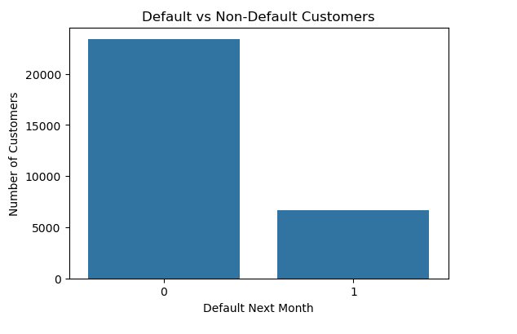
Note: 0 represents non-default customers and 1 represents default customers.
Figure 1: Default Distribution of Customers

Methods
Python programming language was used for the analysis in a Jupyter Notebook environment. The primary libraries utilized included pandas, numpy, matplotlib, seaborn, and scikit-learn.
Exploratory Data Analysis (EDA) techniques were used to better understand the dataset and identify patterns, distributions, and relationships between variables. Visualization methods such as count plots, boxplots, histograms, heatmaps, and confusion matrices were used to support interpretation.
The dataset was divided into training and testing subsets using an 80/20 train-test split. The training set contained 24,000 observations used for model development, while the testing set contained 6,000 observations used to evaluate predictive performance on unseen data.
Two machine learning models were developed for comparison:
Logistic Regression
Random Forest
Because the dataset was imbalanced, Random Forest was expected to perform better than Logistic Regression in identifying default cases.
The following evaluation metrics were used:
Accuracy
Precision
Recall
F1-score
ROC-AUC
Confusion Matrix

Analysis
The analysis focused on identifying important patterns, relationships between variables, and evaluating model performance.
The target variable “Default_Next_Month” represented whether a customer defaulted on their payment obligation during the following month. A value of “0” represented non-default customers, while “1” represented default customers.
The repayment history variables “PAY_0” through “PAY_6” represented customer repayment status over the previous six months. “PAY_0” represented the most recent repayment status from September 2005, while “PAY_6” represented the oldest repayment status from April 2005.
The variables “BILL_AMT1” through “BILL_AMT6” represented total outstanding statement balances for each month during the same period. These variables helped measure customer debt levels and repayment trends.
The repayment history variables were among the most important predictors because they directly reflected customer payment behavior. Customers with repeated late payments demonstrated significantly higher probabilities of default.

Gender Analysis
The “Default Distribution by Gender” chart showed that male customers had a slightly higher default rate than female customers. Approximately 24.2% of male customers defaulted compared to 20.8% of female customers.
Although the results showed some differences between genders, the findings should be interpreted carefully. Gender alone should not be considered a direct cause of default because many additional social and financial factors may influence repayment behavior.
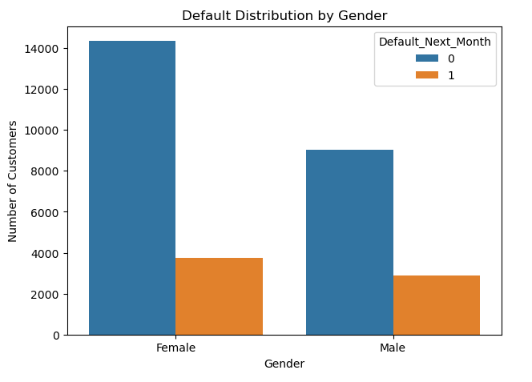
Figure 2: Default Distribution by Gender

Age Analysis
The “Age Distribution by Default Status” chart showed that default rates were generally higher among younger customers and gradually declined as age increased.
Default activity increased significantly between approximately ages 21 and 29 before declining steadily among older age groups. One possible explanation is that younger consumers may engage in more impulsive spending behavior, while older consumers may become more financially cautious over time.
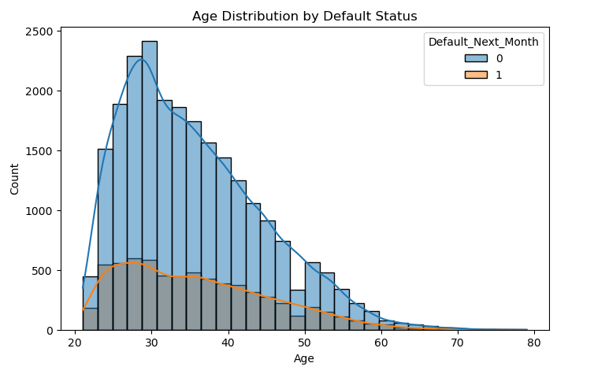
Figure 3: Age Distribution of Defaulted Customers

Credit Limit Analysis
The “Credit Limit by Default Status” boxplot indicated that customers with lower credit limits generally showed higher default tendencies compared to customers with larger credit limits.
This relationship may suggest that customers with stronger financial profiles and higher repayment ability are often approved for larger credit limits, while customers with weaker financial histories may receive lower credit limits.

Correlation Analysis
The “Correlation Heatmap” demonstrated that repayment history variables such as PAY_0, PAY_2, PAY_3, and related payment status variables had some of the strongest relationships with default risk.
Bill statement variables and payment amount variables also demonstrated moderate relationships with default behavior, but repayment history appeared to be the strongest overall indicator.

Repayment Status Analysis
Repayment history proved to be one of the strongest predictors of default risk.
The “Default Rate by Repayment Status” chart showed that customers who were current on their payments generally had relatively low default rates. However, the probability of default increased dramatically once customers became delinquent.
Customers who did not use their credit cards had a default rate of approximately 13.2%. Customers who paid their balances in full showed a default rate, near 16.8%, while customers who carried revolving balances but remained current had the lowest default rate at approximately 12.8%.
Once customers became delinquent, default risk increased substantially. Customers who were one month late had a default rate of approximately 33.9%, while customers who were two months late showed default rates above 69%.
These findings suggest that early missed payments may serve as important warning signs for future financial distress. Monitoring repayment behavior closely after the first missed payment may allow banks to intervene before customers fully default.
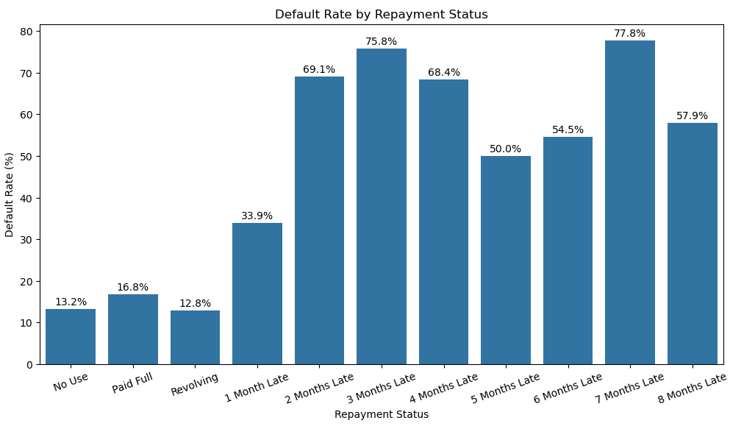
Figure 4: Default Rate of Customers by Repayment Status

Education Analysis
The “Default Rate by Education Level” chart showed some differences between education groups, although the relationship was not extremely strong.
Customers with graduate school education demonstrated a default rate of approximately 19.2%, while customers with university education showed a default rate near 23.7%. Customers with only high school education demonstrated the highest default rate at approximately 25.2%.
Although higher education appeared to be associated with somewhat lower default rates, the differences between groups were relatively moderate. This suggests that education alone is not a strong predictor of default risk.

Logistic Regression Results
The Logistic Regression model produced the following performance metrics:
Accuracy: 0.81
Precision: 0.69
Recall: 0.24
ROC-AUC: 0.73
The model demonstrated strong performance in identifying non-default customers but struggled to correctly identify many default cases because the dataset was imbalanced toward non-default customers.
The Logistic Regression confusion matrix showed:
True Negatives: 4,549
False Positives: 138
False Negatives: 1,002
True Positives: 311
The model correctly classified approximately 75.8% of all observations as non-default customers and correctly identified approximately 5.2% as default customers. However, the relatively large number of false negatives indicated that many risky customers were incorrectly classified as financially safe.

Random Forest Results
The Random Forest model produced slightly stronger results:
Accuracy: 0.816
Precision: 0.64
Recall: 0.37
ROC-AUC: 0.76
The Random Forest confusion matrix showed:
True Negatives: 4,413
False Positives: 274
False Negatives: 830
True Positives: 483
Random Forest performed slightly better than Logistic Regression, particularly in identifying default customers. The model achieved higher recall and ROC-AUC scores, indicating improved ability to detect risky accounts.

Feature Importance Analysis
The “Top 10 Important Features” chart generated from the Random Forest model showed that PAY_0 was the single most important predictor of default risk.
This finding suggests that the most recent repayment status plays a major role in determining whether a customer is likely to default in the following month.
Other important variables included Age, BILL_AMT1, Credit_Limit, BILL_AMT2, and PAY_AMT1. These variables likely captured customer debt burden, payment behavior, and overall financial stability.
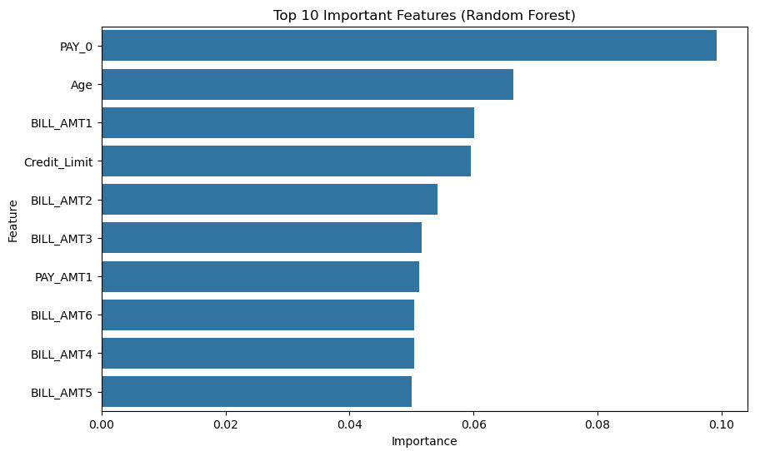
Figure 5: Shows Top 10 most important Features

Conclusion
The analysis demonstrated that repayment history variables played a major role in predicting credit card default risk. In particular, PAY_0, representing the most recent repayment status, was identified as the strongest predictor of future default.
The results also showed that once customers begin missing payments, the probability of future default increases substantially. Early delinquency appears to be an important warning signal for financial distress.
Age demonstrated some relationship with default behavior, with younger customers generally exhibiting higher default rates compared to older customers. Education level showed weaker relationships with default risk.
The Random Forest model performed slightly better than Logistic Regression, particularly in identifying default customers within the imbalanced dataset.
Overall, the project demonstrated that machine learning techniques can provide useful tools for predicting credit card default risk and assisting financial institutions with portfolio monitoring and risk management.

Assumptions
This project assumed that the dataset accurately represented real credit card customers and that the variables provided in the dataset were valid and reliable.
It was also assumed that repayment behavior observed within the dataset reflected meaningful financial behavior patterns that could be used for predictive analysis.

Limitations
Several limitations exist within this study.
First, the dataset represented customers from Taiwan and may not fully generalize to customers in the United States or other countries because consumer behavior, banking regulations, and economic conditions may differ.
Second, the dataset did not contain additional potentially important variables such as customer income, employment status, occupation, spending categories, or credit scores.
Third, the dataset was highly imbalanced, which negatively affected the models’ ability to identify minority default cases.
Finally, it is unclear whether the data represented customers from multiple banks or only a limited number of financial institutions.

Challenges
One major challenge involved working with an imbalanced dataset where non-default customers significantly outnumbered default customers.
Another challenge involved interpreting customer behavior without access to additional financial or demographic variables that may influence repayment ability.
Additionally, financial behavior is influenced by many external economic factors that were not captured within this dataset.

Future Uses and Additional Applications
The models and analytical techniques used in this project could potentially be applied to other forms of financial risk analysis.
For example, similar machine learning approaches could be used to predict risk associated with personal loans, auto loans, mortgages, student loans, or other consumer lending products.
Financial institutions may also use similar techniques for fraud detection, customer segmentation, or portfolio risk management.

Recommendations
Financial institutions should closely monitor customers who begin missing payments because early delinquency appears to be one of the strongest indicators of future default risk.
Banks should consider implementing proactive intervention strategies for financially distressed customers, such as payment assistance programs, temporary hardship relief, or increased account monitoring.
Financial institutions should also continuously update and retrain predictive models as economic conditions and customer behaviors evolve over time.

Implementation Plan
The predictive models developed in this project could be integrated into bank risk management systems to monitor customer repayment behavior continuously.
Accounts identified as high risk could be flagged for additional review or early intervention.
Periodic retraining and model updates should be performed to maintain predictive accuracy under changing economic conditions.

Ethical Assessment
The dataset used in this project originated from a well-known public academic source and contained no personally identifiable information such as names, account numbers, or social security numbers.
The analysis was conducted strictly for educational and research purposes.
Although machine learning can improve efficiency, financial institutions should avoid relying entirely on automated systems when making lending decisions. Human oversight remains important because predictive models may contain bias or produce inaccurate classifications.
Additionally, demographic variables such as gender or age should be interpreted carefully to avoid unfair discrimination against particular groups.

10 Audience Questions
1. Why did Random Forest perform better than Logistic Regression?
2. Why was recall relatively low?
3. Which variable was the strongest predictor of default?
4. Why is repayment history so important?
5. Could this model work in the United States?
6. Why were younger customers more likely to default?
7. Did education strongly affect default risk?
8. Why is class imbalance important?
9. Could banks use this model in real time?
10. Could additional variables improve model performance?

Appendix
The analysis for this project was conducted using Python within a Jupyter Notebook environment. Libraries used included pandas, numpy, matplotlib, seaborn, and scikit-learn.
The full implementation and code are available on GitHub:
https://github.com/maxbilenkin/BellevueUniversity

References
UCI Machine Learning Repository. Default of Credit Card Clients Dataset.
Kaggle. Default Payments of Credit Card Clients in Taiwan from 2005.
Federal Reserve Bank of St. Louis. (2026, February 24). Delinquency Rate on Credit Card Loans, All Commercial Banks (DRCCLACBS). Federal Reserve Economic Data (FRED).
Qi, Z. (2025, June 19). Research on credit card transaction risk prediction model based on multi-source data fusion and its application. Harrisburg University of Science and Technology.

